Dimension of waste water pipe

We plan a gravity separated sewer system. First we have to define the quantity of design waste water at the designing point. Then we assume a slope of the conduit. (we check the longitudinal section, is it proper for the ground?). The value of the slope must be between about 3 ‰ and 50 ‰. (D/100 ≤ I ≤ D/1000, D (mm)) If we have got the design waste water, and a slope we have to assume a pipe diameter. The pipe diameter must be larger than 200 mm. We give this minimum value by the public sewer, because this diameter can be cleaned with canal cleaner. If we have got a slope a diameter, we have to check is these values adequate for the waste water load. We use for the checking the Prandtl-Kármán-Colebrook formula, what gives us the velocity of the waste-water in the full-section pipe. This formula can be applied to the gravity sewers designing. The load results from water velocity ($Q=v⋅A$), A is the cross-sectional area of the pipe).
$v_{\text{tot}}=\left[−2\text{lg}\left(\frac{2,\text{51}υ}{d\sqrt{2\text{gId}}}+\frac{k}{3,\text{71}d}\right)\right]⋅\sqrt{2\text{gId}}$ 1.1 formula
$v−$the water velocity (m/s)
$υ−$the kinematic viscosity of the waste-water 1,31*10⁻⁶ m/s²
$g−$acceleration of gravity (9,81 m/s²)
$I−$ the slope of the conduit (m/m)
$d−$diameter of the pipe (m)
$k−$ roughness of pipe wall (0,0025 m)

If we get the waste-water velocity, we have to check the velocity, and the minimal water depth in the sewer 3-4 cm, because the blockage or siltation. The real velocity of the waste-water must be 0,4-2,0 m/s. We can get the real water depth and the real velocity with next graph 1.1..

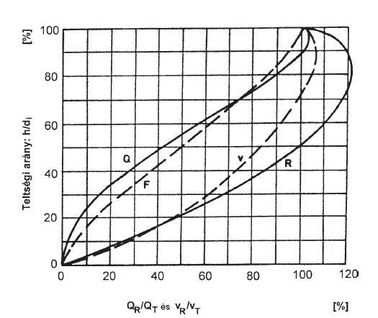
Plenum coefficient h/d
Q_{real}/Q_{tot} and v_{real}/v_{tot}

1.1. graph: Plenum curve
If we want get the real water velocity, and real water depth we have to calculate the total transported quantity, what the pipe can transport.

$Q_{\text{tot}}=v_{\text{tot}}⋅A$ 1.2. formula

$Q_{\text{tot}}−$water flow with full section (m³/s)
$v_{\text{tot}}−$water velocity (m/s) derives from 1.1. formula
$A−$ cross sectional area of pipe (m²)

Then we have to compute the next ratio:

$\frac{Q_{\text{real}}}{Q_{\text{tot}}}$ 1.3. formula

$Q_{\text{real}}−$ the planning flow volume at the designing point (m³/s)
$Q_{\text{tot}}−$water flow with full section (m³/s)

If we have the ratio of Q_{real}/Q_{tot} we have to search this value on the horizontal shaft of the plenum curve. We have to project this value to the curve „Q”, then we have to project the intersection we got, to the curve „v” horizontal. Then we get another section, and we have to project this section to the horizontal shaft. The value we got on the horizontal shaft is the v_{real}/v_{tot}. This method can be seen on the graph 1.1. (red line). We can calculate the real velocity from this ratio and from v_{tot} (velocity of the waste-water in the full-section pipe).

$v_{\text{real}}=v_{\text{tot}}⋅\frac{v_{\text{real}}}{v_{\text{tot}}}$ 1.4. formula

Finally we have to calculate the water depth, the method can be seen on the graph 1.1. (blue line) We have to read the value h/d from the vertical shaft. We get the real water depth as it follows:

$$h=d\frac{h}{d}$$

$d−$pipe diameter

Finally we check the real water velocity, the real water depth, is it adequate for the rules, if the values aren’t adequate we have to modify the slope or the pipe diameter until the result is satisfaying.
Dimension of storm water pipe

The dimension of the storm water pipe is similar to the waste-water pipe. First we have to define the load of the storm water. We have to define the catchment, what belongs to the designing point. First we have to border the catchment. We mark the area, wherefrom the storm water flows to the designing point. Then we draw our sewer on the area. We can lay our sewer just on area of common use. We have to measure the sewers length. We use the rational method to the design. The theory of rational method is the next. The time of concentration is equal to the period of the design storm. The time of concentration (T) has got two parts (figure 2.1.):

- the runoff on surface T₁
- the runoff in the sewer T₂

T1
T2 (L,v)

2.1. figure

T= T₁+T₂ (min)

We calculate the time of concentration from the farthest point. The run off on surface is given on the worksheet. This value depends on the slop of the surface the length on the surface the quality of surface. We have to calculate the runoff in the sewer if we assume the water velocity in the pipe 1 m/s (v) and we know the length of sewer (L).

$$T_{2}=\frac{L}{v}$$

The next step we calculate precipitation intensity whit this formula:

$i_{p}=a⋅(\frac{T}{\text{10}})^{−m}$ (l/s ha)
Where:

$T−$ the time of concentration (min)
$a,m−$this value belong to rate of occurrence (see next table 2.1.)

Rate of occurrence | A | M
1 year | 133 | 0,69
2 years | 203 | 0,71
4 years | 270 | 0,72

2.1. table

We calculate the load of storm water at the design point with next formula:

$Q=i_{p}⋅A⋅α$ (l/s)

Where:

$i_{p}−$ precipitation intensity
$A−$ area of catchment
$α−$ run-off coefficient

The run-off coefficient depends on the surface for example run-off coefficient of the covered surface is higher value than uncovered. This value can be seen on the worksheet.
If we have the load of the sewer at the design point. We can calculate the diameter of the pipe with Prandtl-Kármán-Colbrook formula. Then we have to check the real water velocity, and water depth. See by the waste water design method. If the difference is between the calculated real water velocity and assumed water velocity more than 20 per cent we have to change the slope or diameter of pipe until the difference lower than 20 per cent. We have got other possibility to correct the failure, for example we can change the assume water velocity.

